【例4-17】feather函数绘图1
>>x=1:0.01:20;
>>feather(x)
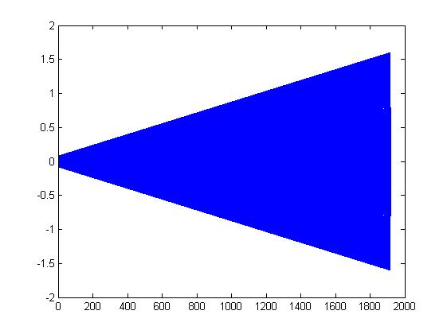
图4-17 feather函数举例(1)

